

Name:Sundas Ambreen
Class:BSCS
SAP ID:58822
Course: Data Structures
Assignment 3

Task:
The goal is to implement a Binary Tree where internal nodes are operators and leaf nodes are operands, and then use the three standard traversals to generate the Infix, Prefix, and Postfix expressions.
Step 1: Define the Node Structure
Step 2: Implement the Node Creation Function.
Step 3: Implement Traversal Functions
3a. Infix Traversal ( Left-> Root -> Right)
3b. Prefix Traversal (Root -> Left-> Right)
3c. Postfix Traversal (Left-> Right -> Root)
Step 4: Construct the Input Tree (Main Function)
Solution:
#include <iostream>
using namespace std;

// Step 1: Node structure
struct Node {
char data; // this can be an operator or operand
Node* left;
Node* right;
};

// Step 2: Function to create a new node
Node* createNode(char value) {
Node* newNode = new Node(); // memory allocation
newNode->data = value; // store data in node
newNode->left = NULL;
newNode->right = NULL;
return newNode;
}

// Step 3a: Infix traversal (Left -> Root -> Right)
void infix(Node* root) {
if (root == NULL)
return;

if (root->left && root->right) cout << "("; // for clarity
infix(root->left);
cout << root->data;
infix(root->right);
if (root->left && root->right) cout << ")";
}

// Step 3b: Prefix traversal (Root -> Left -> Right)
void prefix(Node* root) {
if (root == NULL)
return;
cout << root->data;
prefix(root->left);
prefix(root->right);
}

void postfix(Node* root) {
if (root == NULL)
return;
postfix(root->left);
postfix(root->right);
cout << root->data;
}

int main() {

Node* root = createNode('*'); // root operator
root->left = createNode('+');
root->right = createNode('-');

root->left->left = createNode('A');
root->left->right = createNode('B');

root->right->left = createNode('C');
root->right->right = createNode('D');

cout << "Infix Expression: ";
infix(root);
cout << endl;

cout << "Prefix Expression: ";
prefix(root);
cout << endl;

cout << "Postfix Expression: ";
postfix(root);
cout << endl;

return 0;
}
Output:
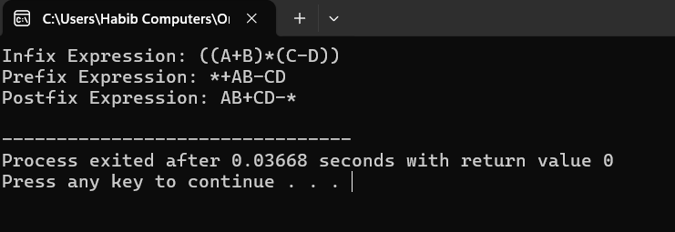
1.Tree Nodes:
Each node holds one value either an operator like +, -, or an operand like A, B.
2. Tree Building:
I connected all nodes to form the expression (A + B) * (C - D).
3. Traversals:
- Infix gives output in normal human-readable form.
- Prefix shows operator before operands.
- Postfix shows operator after operands.
Result:
The same expression is displayed in three different formats using the same tree.

